**Compsci 314**

**Assignment 2**

Due date: 22nd September 2019

Part 1: The FTP Protocol

1.1 Which port number is used for this FTP Connection?

Answer: Source port 21

1.2 What Usercode and Password are used to log in to FTP?

Answer: Usercode: anonymous

Password: a@a

1.3 Why is FTP mode switched to Binary?

Answer:

1.4 What FTP command is used to download the test file?

Answer: The GET command or the raw command RETR. But more of GET command to download the test file.

Part 2: Data bytes transmitted by TCP

2.1. What well-known port number is used for FTP data?

Answer: Port 20 is used for FTP Data

2.2. What are the packets and sequence numbers for the file transfer’s opening SYN?

Answer: Packet 25 and sequence number 3542284279 is for the file transfer’s opening SYN.

2.3. What are the packets and sequence numbers for the ACK to the file transfer’s closing FIN (i.e., the FIN from the FTP data sender)?

Answer: Packet 2423 and sequence number 2581412675 is for the ACK to file transfer’s closing FIN.

2.4. How many actual data bytes were sent by the file transfer?

Answer: Step 1. Find the sequence number of the ACK segment immediately after the SYN+ACK segment. This is the sequence number of the first ftp-data byte which is 3542284279.

Step 2. Find the acknowledgement number of the FIN+ACK segment (sent by the client) which is 3552770040.

Step 3. (The result of Step 2) - (The result of Step 1) – 1

3552770040 – 3542284279 – 1 = 10485760

The actual data bytes sent by the file transfer is 10,485,760

2.5. What was the size of the transferred file?

Answer: 10,485,760 bytes

Part 3: Packets retransmitted by TCP

3.1. How many packets are displayed using this filter?

Answer: 1614 packets are displayed using this filter.

3.2. How many retransmitted packets does Wireshark display?

Answer: 3 packets are displayed using this filter.

3.3. How does Wireshark recognise a packet retransmission?

Answer: Wireshark compares the sequence numbers to what it has determined to be the next expected sequence number from the last packet of the conversation into the same direction by packet order.

3.4. What is the observed packet loss percentage for this trace file?

Answer: 0%

Part 4: Protocol overhead

4.1. In question 2.5 you determined the number of data bytes transferred. How many bytes were actually sent during that transfer?

Answer: 10,573,508 Bytes were actually sent during the transfer.

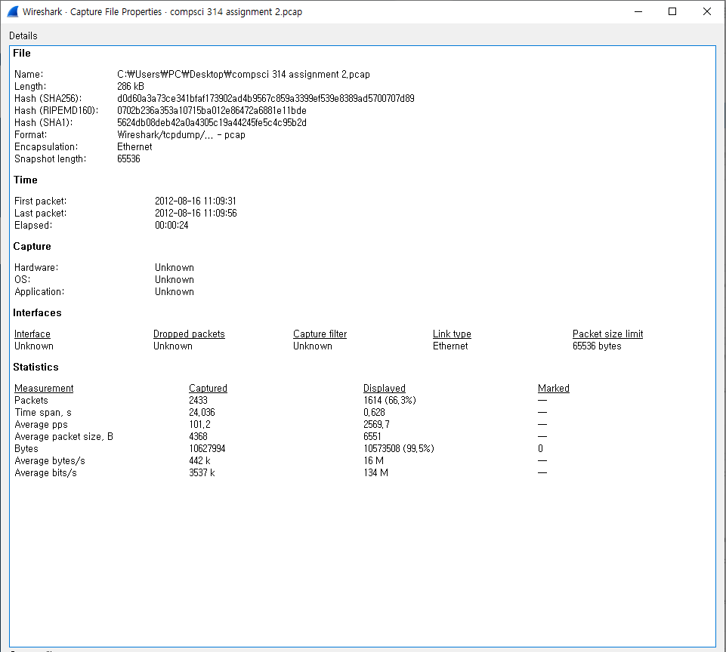

Way to get to the screenshot on wireshark is Statistics tab -> Capture File Properties -> Displayed bytes.

4.2. What was the percentage of “protocol overhead” for that file transfer?

Answer: 10,573,508(Actual bytes) - 10,485,760(Q2.5 size) / 10,573,508(Actual bytes) = 0.008298 4s.f.

Therefore, the percentage of “protocol overhead” for the file transfer is 0.8298%

4.3. What parts of the packets contributed to that overhead?

Answer:

Part 5: Round-trip time

5.1. What is the most common Round-Trip Time (RTT) for packets from sender and receiver and back?

Answer: In the range of 0.3 ms to 0.4ms is the most common RTT for packets from sender and receiver and back.

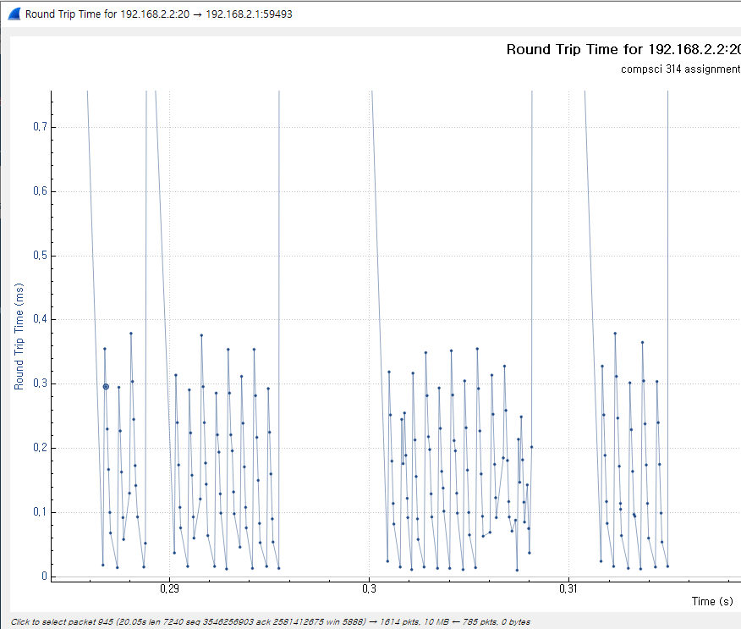

By Se ho Lee